PC Controller PCB (PCB2) Users Guide 18.02.06

PC Controller PCB (PCB2) Users Guide 18.02.06 1
Included in PCB2 Package 1
Not Included in Package 1
Warranty and Repair Policy 2
Overview of PCB2 2
PCB2 Circuit Description 3
PCB2 and PCB1 Block Diagram 6
PCB2 Overlay showing major subsections. 7
Interactive Software Functionality to be provided 7
Suggested Optional PC & peripheral Devices 8
Test Software 9
Copyright 9
Using PCB2 9
Connecting things up 10
LCD Display 10
Stereo Amplifier 10
PCB1 – 4 Motor Controller Connector 10
Serial Port 11
Parallel Port 11
Four RC Receiver Inputs 11
Using the Qbasic Test Program 11
PCB Modification to fix PIC Start-up Problems 11
How to build LED test boards for both PC digital outputs and Decade counter outputs 12
Serial Servo Control 13
Aligning the High Current Digital Output Switch POTs. 13
Analogue Input Mappings 14
Tested Sensors 14
Optional Components on PCB2 15
Making DIGITAL OUTPUT connections 15

Included in PCB2 Package
- The kit and fully assembled unit includes all components on the PCB plus cables and connectors for the connection of the serial and parallel port to your computer. The cable for connection to PCB1 is also included.
- Documentation and sensor wiring and positioning examples are provided in this document.
- A QBasic program is provided that exercises all parts of the PCB.
- A Vbasic exe is available for testing the servo functions of the PCB.
- I will provide an extended version of the QBasic program in the future for a specific Interactive R2D2 implementation. This will be available as I bring my own R2D2 to life.
- I may also write a Vbasic version of both the test program and extended version. This will be available for a small fee.

Not Included in Package
- The kit can interface to a variety of sensors including IR Diodes, LDRs, PIRs and Microphones.
These are not included in the above Kit or Fully Assembled unit.
- Each user will likely have differing requirements for sensors. For example some may choose not to implement the Collision Detection sensors whilst others many choose not to use PIRs.
- Examples of sensors and their part numbers and suppliers are included in this document.
- Wiring to the laptop for the line out connection, speaker wire, volume control pot and speakers are not provided.
- All of these are common low cost parts and should be able to be sourced at a lower price at your local Electronics shop – e.g. Tandy.

Warranty and Repair Policy
DOA
If assembled controller proves to be Dead on Arrival within 10 days of date of delivery it will be repaired free of charge excluding freight. The customer will pay freight and any duty/taxes to my address in Australia. I will pay freight but not duty/taxes to the return address after repair.
One Year Warranty
My warranty is limited to One Year from the date of Shipping for products that fail during normal use. The products shall be repaired at a fixed warranty price ($75.00) as published in the price list.
The customer will pay freight and any duty/taxes to my address in Australia.
I will pay freight but not duty/taxes to the return address after repair.
This warranty does not apply to products that have been mistreated as determined by my judgment. Mistreatment includes but is not limited to damage due to incorrect battery polarity, submersion, mechanical or electrical modification including incorrect fuse values, unsupported sensor connections, static discharge or shorting damage and unauthorized repairs.
Beyond One Year Warranty
Units may be repaired after the one year warranty period at a price to be quoted upon inspection.
The customer will pay freight and any duty/taxes to my address in Australia.
I will pay freight but not duty/taxes to the return address after repair.

I give no other warranty; either expressed or implied and disclaim all other warranties, including warranties for merchantability, fitness, or infringement. This warranty is not transferable. In no event shall my liability exceed the buyer's purchase price, nor shall I be liable for any indirect or consequential damages, injury or death incurred through the use or misuse of this product.

Pricing, software and hardware Specifications for PCB2 can change without notice and I will not be liable for any changes.

Overview of PCB2

The PC Controller PCB provides a set of I/O functions to allow a standard PC, laptop or mini PC (Such as Viatech) to interface with a robot or other external device. The functions and mappings described in this document have been written around interfacing with an R2D2 style Robot but the PCB could be used with any Robotic system that requires PC control.

Also provided with this PCB2 package is a Qbasic program with a series of subroutines that allow all the functions of the PCB to be tested. These subroutines can be “cut and paste” by the user to allow customised interfacing with their robot. I will also be providing a complete software environment based on Windows 98 that will work with modest PC/Laptop HW (100-300Mhz) that will include a version of the aforementioned Qbasic program plus other executables and sundry files to allow a complete “turnkey” solution for an interactive R2D2 when coupled with PCB1. This will give the robot advanced features including interactive voice recognition.

Note that my PCB1 (4Motor Controller) is not specifically required for PCB2. However I will not be able to support the software for solutions that do not use PCB1 since the software mappings for the Motors will mach the layout of PCB1. In addition, PCB1 provides the 5V and 12V power and power monitoring input required for PCB2 mapped nicely onto the ribbon cable that interconnects the two PCBs. PCB1 also provides a 3amp 15V output for powering a laptop directly. Please email at mhamester@yahoo.com for more information regarding PCB1.

Note that PCB2 assumes the user is reasonably experienced with electronics and software and can make changes to Qbasic software and connect up LEDs, motors, sensors and power without blowing things up! If you have no experience, make sure you tee up with a fiend who does, or do not attempt to use this system.
I will not be responsible for PCBs that are damaged due to incorrect wiring and or failure to READ everything I write about the product BEFORE turning the power on.

I expect that other robot builders using these PCBs and software will come up with their own software and sensor arrangement and offer these ideas and support to other club members.

PCB2 Circuit Description

The following block diagram shows the major blocks in PCB2 and PCB1.
I explain the functions of PCB2 here at a high level. Analysis of the cct diagram (provided with shipping units) will provide more detail.

8 Channel Serial Data Servo Inputs
A serial port operating at 2400bps allows serial Servo PPM commands (coming from the Qbasic or C etc. program) to be interpreted by the 8 Channel Serial to PPM PIC Controller. Four of these channels (channel 1-4) are directed to the 4way tri-state switch on the 4Motor controller (PCB1) via the 16 way header located on both PCBs.

The 4Motor controller (PCB1) 4 way tri-state switch allows selection from two sets of 4 PPM inputs using a SPST switch.
I.e. The first set of four come from your external RC receiver which is also plugged into PCB1 and the second set comes from PCB2, which offcourse comes from your computer program.

The 2nd set of four PPM channels (channel 4-8) that are output from the PIC controller on PCB2 are directed to another 4 way tri-state switch this time on PCB2. This tristate switch allows selection of two sets of 4 PPM inputs again using a single SPST switch.
(The SPST switch from PCB1 can be ganged with the SPST switch from PCB2 so that both banks are switched with a single switch – in this case the switch is a DPST. This allows your robot to have all 8 channels switched between the RC receiver and the computer program with a single switch).

The remaining four PPM inputs fed into the tri-state switch on PCB2 come from the remaining 4 channels from your external RC receiver. (This is assuming you have an 8 channel RC receiver).

The 4 tristate outputs from the tristate switch on PCB2 are treated as follows;
Two of the outputs are passed directly to a 3 pin headers on the PCB2 to allow the connection of 2 standard servos. These servos can be therefore be driven from the RC transmitter, or computer control.

Four High Current Digital Switch Outputs
The remaining two outputs from the tristate switch are passed to the inputs of four Servo switches.
These Servo switches take a 1-2mS ppm signal and based on a pot setting turn the digital output off below a particular value and on above that same value.
By using two of these digital servo switches per. PPM channel, and inverting the input, it is possible to get two switched outputs from a single RC channel. This allows 4 digital switches to be provided from just 2 PPM channels.
Again, these two PPM signals can be sourced from either the RC transmitter or computer software depending on the position of the SPST switch.

The outputs of the 4 digital RC switch outputs feed 4 high current N channel MOSFET switches for driving high current devices such as halogen lights, DC motors, Relays or solenoids.

All this provides the ability to drive the 4 high current switches from either two RC channels on the RC transmitter or via computer software. In other words, you can turn on and off the same devices, e.g. lights or claw or whatever using either RC or computer control.

Parallel Port I/O System

The Parallel port section of PCB2 provides the bidirectional interface for Software control of up to 16 digital outputs, 11 analogue inputs and a 16x2 line LCD status display.
Typically the digital outputs will be used to drive low current devices such as LEDs or small relays using the bilateral switch outputs.
The 11 analogue inputs are used for reading sensor information. Sensors can include but are not limited to Infrared, Light, Sound, temperature and Ultrasonic devices. They can be used to get feedback for software such as collision/avoidance detection, dome position, Sound location, Sound triggered event, temp or light triggered event etc.
Sensors other than the ones I describe in the wiring examples can be used as long as the sensor can be connected so as to provide a 0-5V analogue input.

The Parallel port is written to and read from using Qbasic I/O statements.
Although the Parallel port is as the name implies, a parallel bus, the I/O setup uses the port in a serial fashion by writing serial data to two shift register/latch chips and reading from an 11 channel Serial ADC.

Digital Output Details

There are 16 x digital low current common collector (100mA) outputs for driving dome LEDs etc.
These outputs can also be used to open/close R2 body panels with a suitable low power mini solenoid, or drive small relays. I will provide circuit examples.

11 Analogue Input Details

Rather than just leave the inputs generic, I have provided conditioning electronics to provide the following input applications..
- 4 x conditioning ccts for external IR Collision avoidance inputs
- 2 x inputs for external Darlington light sensor inputs
- 2 x inputs for external miniature PIR movement sensor in dome
- 1 x LM 380 sound sense input for external electret mic.
- 1 x 24v Battery Voltage sense input to provide low battery warning
- 1 x motor Position sense using external POT feedback input. Note; If using motor controller servo pot on PCB1 for motor (eg Dome) position feedback, then above motor Position input could be used for another function e.g. a 3rd PIR sensor, or RC on/off sense input

Note that if you understand electronics, you could adapt these inputs to suit your application quite easily.
In this case I suggest you go for the kit version.

Stereo 2.5 Watt Audio Amp
Two LM380 2.5 Watt Audio Amp chips are provided.
The PC/Laptop sound card output connects to the input of these amps. (Cable not included)
Each amplifier can drive an 8 ohm speaker. I have tested the volume and it is LOUD!
A stereo rotary pot based Volume control header is provided on the PCB but the pot is not included.
I will recommend a suitable rotary pot.

16x2 Character LCD status Display
One of the difficulties with putting a PC into a robot is the fact that you don’t have a VGA monitor attached (except when you are developing your code or controlling the robot via a WLAN link) and so it is hard to know if your control program is running or what routine is currently being executed. One solution is to include a WLAN connection in the PC/Laptop and use something like VNC Windows remote control software to provide a virtual monitor remotely.
This remote monitor is handy around the house but difficult in a convention hall, or down at the local theatre!

To address this problem the PCB2 includes a standard 16x2 Hitachi LCD display connected to the parallel port off a header on PCB2. The parallel port device selection signalling has been designed so that the digital output and analogue input signal don’t interfere with the LCD (and visa versa)…

Using a 16 way ribbon cable, this display can be mounted remote from the PCB somewhere on the body of the robot (within a metre or so) - or it can be mounted on top of the PCB on a header as per my prototype.
In addition to displaying the state of the program, it can be used to show the voltage at any analogue input or the state (low/high) of any analogue output. PCB1 provides a 24V voltage sense output (voltage divider) that the LCD display can read (via software). This provides an immediate view as to the state of the Robot’s battery power. This could be translated in software into a “time remaining till recharge required” display.

The LCD could also be used for example in an R2D2 robot to show the phrase in English that R2 is “saying” in his droid language. The LCD messaging possibilities are endless and only limited by your software writing creativity!

The LCD also supports symbol characters for the advanced user.

Infrared LED oscillator Cct (transmitters for IR collision avoidance inputs)

A header has been provided for the connection of four IR LEDs to an IR LED oscillator.
This is designed to allow up to four collision avoidance sensors to be connected to facilitate a semi autonomous robot in conjunction with the software. There are four matching analogue IR Sensor Inputs. I will be writing Qbasic code that will utilise these avoidance sensors.
Each IR sensor provides a DC voltage that is proportional to the received signal strength. Software is written to trigger a proximity event when this DC voltage crosses a rising or falling threshold.

Decade counter for driving Dome LEDs

Rather than wasting the individually programmable 16 digital outputs for driving dome LEDs (these should be reserved for solenoids & motors etc) I have provided a decade counter chip that can sequence 10 or more (I have tested 30 by ganging 3 LEDs to each output) LEDs. The decade counter may be clocked (flash rate) from one or more of the following sources;

- 555 Oscillator IC. The frequency of the clock may be adjusted through the use of an onboard trim POT. You could if you like remove this onboard POT and mount and external screw POT. – For example inside a front panel of R2.

- External sound source. The audio output signal from the LM380 sound input chip may be “tapped” to provide an oscillating input for driving the decade counter. This allows you to provide LED displays that flash in sync with ambient sounds – providing an “R2 is listening” effect.

- Digital output 16. This allows your program to control the frequency of the flashes.

Any or all of the three inputs may be “mixed” using a link block on the PCB. For example, you may wish to use all three inputs for the following effect;

- When R2 is in a quite room without the PC powered up; - Slow flash using the 555 timer input.
- When R2 is in a noisy room full of kids; - Slow flash using the 555 timer but speeds up when sounds are present.
- When R2 is under computer control; - flash as in 1 & 2 above, but flash even faster when a particular software routine is being executed. E.g. when R2 is opening a door or moving a claw in or out.

I am designing R2 front and rear dome logic displays to suit the output of the decade counter.

Complimentary Circuits found on PCB1.
Again, whilst not required for PCB2, PCB1 provides the following compatibility.

- Matching 16 way ribbon connector carrying 5V, 12V, Gnd, Battery level and four RC signals.

- Two end-run/collision sense inputs on each motor controller drive to disable the motor at the end of run. e.g. at end of left or right dome rotation. This allows the software program driving the motors not to have to worry about reading an input variable telling it to stop driving the motor.

- Four motor drives. My R2 software will be written to use these as follows;

M1 – Left Drive
M2 – Right Drive
M3 – Dome Drive
M4 – Periscope or claw drive

PCB2 and PCB1 Block Diagram
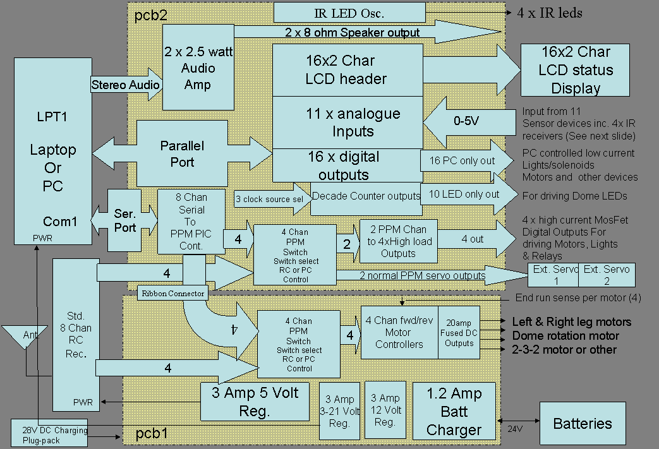

PCB2 Overlay showing major subsections.
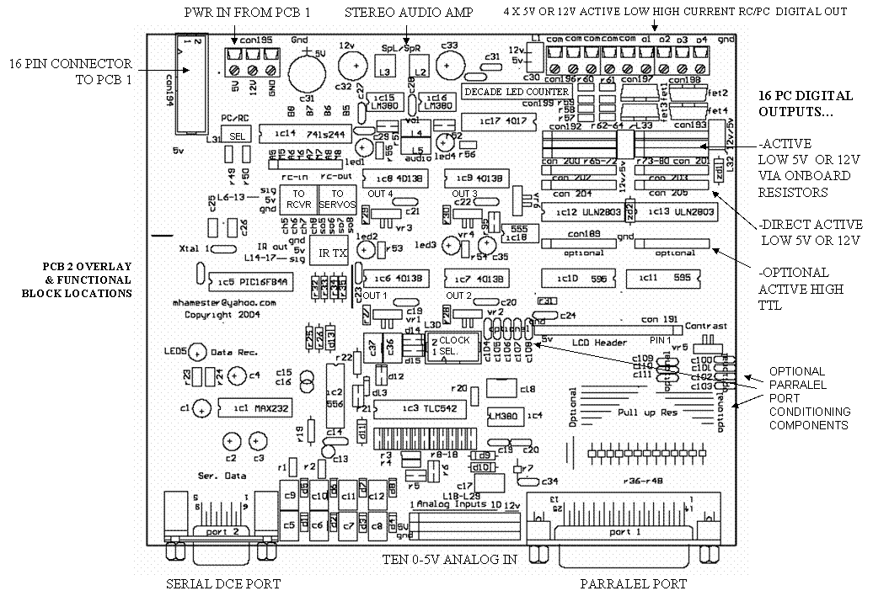

Interactive Software Functionality to be provided

I have already built an interactive R2D2. You can look at examples of what it can do at my web site;
http://members.optushome.com.au/mhamester/index.htm

Using PCB1 and PCB2 and the planned Qbasic software and add on programs, you can build a droid that can do just as much and more than my original. These PCBs are essentially the same electronics plus numerous enhancements as what I implemented in my original R2.

Some of the software functions that are possible are as follows;

- Qbasic Routines
  - 40 Random R2 sounds triggered from sound/light/PIR sensed
  - 40 Random movie sounds – sound/light/PIR sensed
  - HP light and data LEDs triggered from sound/light/PIR sense
  - HP servo movement triggered from sound/light/PIR sense
  - Monitor analogue voltage inputs
  - Display R2 message concurrently with a particular R2 sound
  - Keyboard driven motor routines – main drive/dome
  - Follow the light
  - Autonomous movement with collision avoidance
  - Move dome towards PIR movement
  - Sound sensed LED sequences
- Speech recognition control of R2’s
  - Movement
  - Lights
  - Sounds
  - Operating Modes
  - Note that you need a Pentium 90 or better to play MP3 files..
- This list is incomplete and will be added to as I or others think of new functions
- Functions are also dependant on optional Hardware in R2
  - E.g. retractable Claw, Periscope, servo or switch controlled panels
- Note that Windows XP, NT, 2K are not supported for the Qbasic environment because Qbasic cannot address serial/parallel ports in these OS. I am therefore only supporting Windows 98 with my Qbasic software. Windows 95 does not support USB and you will probably want USB for support of Webcams, keyboards etc. You can offcourse write your own software in whatever language you are experienced with…

Suggested Optional PC & peripheral Devices

Recommended PC Hardware
- You can use whatever you like of course, however I have had experience with;
- Laptop – 400Mhz P2 (Used in my original R2)
- VIATECH EPIC 550Mhz mini ITX Motherboard (to be used in my next R2)

The PC/Laptop you choose needs to provide the following I/O

- Parallel port
- Serial Port
- USB port (preferably two)
- Mic Input
- Stereo Output (line or headphone level)
- External Keyboard conn. (although you could use USB keyboard)
- Be Running Win98
- CD Rom Drive (or DVD if you like)
- PCMCIA for WLAN card (could be USB or PCI or built into Laptop)

The Biggest thing to worry about is Battery Load. You should try to minimize battery current by choosing a low power laptop or motherboard.

A laptop that draws less than 3amps can be powered from the 3-22Volts output from PCB1. Just set the trim pot on PCB1 to the correct voltage. E.g. 15V for Toshiba and 18V for Dell laptops.

For a Mboard with ATX power connector there are companies that sell small switch mode power supply modules that run off 12 or 24V and provide a standard ATX power connector with all the voltages. I.e. 5V, 12V, -5V, 3.3V -12V. These are available from www.mini-box.com.

USB Keyboard
As can be seen from my original droid, the ability to enter data from a keyboard into your internal PC can be useful. (Kids love buttons) For example: playing particular sounds, selecting program modes, turning on/off lights. In my original implementation, I hacked a standard 101 keyboard chip and came up with a numeric keypad which I located on the front of the droid. Unfortunately this makes your droid a little unauthentic. A better way to go would be to use a USB keypad and have this accessible via an access bay door in the front or rear of the droid. These USB keypads are available in most electronic/computer stores for about $30.00.

USB Webcam
In my original droid I used two Cameras’, a UHF B&W camera and then later, a webcam.
For good webcam operation you will need at least a 300Mhz Pentium system. Using this in conjunction with a WIFI setup and remote control software like VNC, you can remotely control the droid with combination of video from the main eye and Qbasic keyboard motor control commands…

Test Software

The test software (Qbasic) is complete and will ship with the PCB.
The test software allows all parts of the controller PCB2 (and PCB1) to be tested and includes the following functionality;

- Initialise LCD after power-up
- Send Keyboard Characters to LCD Row 1 and Row2
- Send pre-defined test string to LCD
- Set or reset any of the 16 digital outputs
- Run a strobe pattern at various speeds through the 16 digital outputs (suggest LEDs are connected)
- Read any of the 11 analogue inputs and display voltage (0-5V) on PC monitor or LCD
- Select and set any of the servo outputs 1-8 with a digital value between 1 and 255
- Cycling through all the servo outputs to exercise the servo’s on PCB1 & 2
- Turn on and off the four high current outputs
- Speed up or slow down and reverse selected servo output (assuming motor attached) using keyboard up/down arrows
- Monitor the Battery Voltage
- Monitor all Inputs
- Monitor the Collison inputs on both VGA and LCD

Any of the routines used to perform the above functions can be re-used in your customised robot control program.

Note that this is a working document and will change as further software development is done.

Copyright
PCB2, PCB1, the test software and this document are copyright.
Reproduction in whole or in part is strictly forbidden without the express consent of the Copyright owner:- Mark Hamester. (mhamester@yahoo.com)

Using PCB2

Connecting things up

LCD Display
The LCD display provides a 16x2 program and sensor status display. It connects via a 0.5 metre 34 way ribbon connector. This is a little strange you might say, since there are only 16 pins on the LCD PCB header. The problem is that single row IDC connectors are not available and the alternative solder or crimp styles are expensive and time consuming to manufacture.

The pcb1 LCD header is marked on the pcb. It is also marked as con191.
The end that says 5v is pin 16 – the other end (closest to the con191 label) is pin 1.

Pin 1 on the LCD ribbon connector has a little triangle marked on the female header connector. Connect this end to pin 1 on the pcb1 single row header. As mentioned above, only one row is being used on the two row cable header. Use the row closest to the little triangle at both ends of the cable.

Pin 1 on the LCD PCB is marked. Connect it to pin 1 on the LCD PCB header. There will be a few pins at the end of the female header cable that are not connected to any pins – that is OK.

The only issue may be if you need to install the optional c106-108 caps for parallel port noise reduction. I have not had to do this yet. In this event you could mount these caps on the underside of the PCB.

There is a contrast Pot. (VR5) for the LCD. Turn this fully clockwise and then back it off if needed.

The LCD connector provides the 5v for the backlight function. If you don’t want to have the backlight in order to save power (it draws about 150ma), then you can cut pin 15 of the male header on PCB1 and run a separate switched line to pin 15 on the LCD PCB.

Stereo Amplifier
The stereo amp provides a 2 watt output into two 8 ohm speakers. L2 and L3 are the speaker wire connectors. L5 is the stereo line in input with the centre pin being common. L4 is the volume connector. This needs to be wired to an external Pot. Again the centre pin is common.

You will need a double gang pot, i.e. a ganged pot for each channel, or you could use single pots. It should a logarithmic 10Kohm.

You will need to adjust this Pot. and the PC line out volume to get the right volume level for R2 sounds. Do not attempt to drive 4ohm speakers or the LM380s may overheat. There are chip heatsinks available if you find the chips are getting hot.

PCB1 – 4 Motor Controller Connector
The 16 way ribbon cable with 8x2 female connectors provides the 5V and 12V power from PCB1 to PCB2. These connectors are keyed.

Connector to PCB1 pinnout – 16 pin header

Pin # | Pin2 | Pin4 | Pin6 | Pin8 | Pin10 | Pin12 | Pin14 | Pin16
Function | 12v | 12v | 12v | gnd | gnd | gnd | gnd | Batt-lvl
Pin # | Pin1 | Pin3 | Pin5 | Pin7 | Pin9 | Pin11 | Pin13 | Pin15
Function | 5v | 5v | 5v | Ppm5 | Ppm6 | Ppm7 | Ppm8 | Ppm7

Note that if you are not using PCB1 you will need to provide a 5V and 12V supply – each with at least 1 amp capacity. You can connect this power either to the 5V and 12V terminal block or to the appropriate pins in the interconnect header.

Serial Port

The Serial port is a DCE configuration. A PC is a DTE so a straight through cable is required.
I provide a straight through serial ribbon cable with the package.

Note that the Qbasic and PIC program sets the baud rate and other serial parameters. You cannot use this serial port with hyper term or any other serial console for any useful purpose. I.e. It is only used for sending the PPM position data and servo enable/disable data to the PIC.

Parallel Port
This is a standard PC parallel port. The optional caps and resistors on PCB2 are only required if you have problems with the parallel connection in terms of noise. I have never had to install these and I have used both a desktop PC and laptop. Please email me if you have problems.

Four RC Receiver Inputs
These are located on L6-L9. Two of these are for controlling the four high current digital outputs via 2 PPM channels. The remaining 2 channels can be simply switched to two standard servos. The source for these four high current outputs and two servo outputs may be from your RC receiver or alternatively from the PIC serial chip output. That is, from you RC gear or software control. The position of L31 PC/RC link (or STDP switch that you connect to the link) will determine the input choice. Look at the PCB 1 and 2 Servo Mappings table below for mapping details.

Using the Qbasic Test Program
Make sure you are running Win95 or preferably Win98. Make sure you connect the parallel and serial port cables. Run the Qbasic program from within a DOS window. Follow the instructions in the menus. Note that there are plenty of comments in the Qbasic code explaining what is happening. Hopefully you already understand Basic. If not, now would be a good time to learn☺.

PCB Modification to fix PIC Start-up Problems

I have had some problems with some of the PICs not starting up properly after applying power.
The PIC has a requirement that the 5V rail comes up within a few microseconds. Measurements on PCB2 5V rail have shown that it comes up right on the borderline of this limit. As such the PIC will sometimes not start up correctly.

If you find you cannot communicate with the PIC (used for PC servo commands) this is most likely the problem. The typical symptom of this is that the data LED does not flash when sending servo commands from the Qbasic program – or that the PCB2 “data rec” LED is hard on from power-up. If working correctly, the LED will flash with each serial servo command.

The solution is to add an RC delay circuit to the PIC reset pin 4.
This circuit requires three common passive components (2 x Resistor and 1 x Capacitor).
Probably the easiest way to build this is to solder these three components together, wrap them in electrical tape, and solder three wires to the board. The diagram below shows the circuit and how to attach the wires.

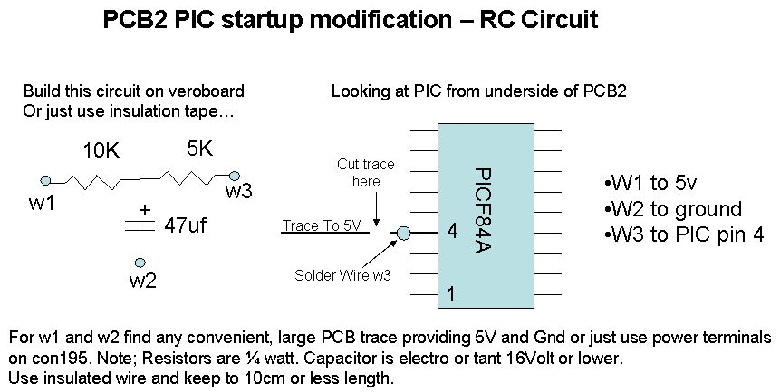

You will need to cut the trace (leaving a 1mm gap) going to pin 4 of the PIC (PIC16F84A) and bare back some of the track resist (paint) such that the wire from you RC circuit can be soldered to it.. The ideal place for the cut is about 1cm from the PIC. Email me if you have problems with doing this. Please ensure the power is disconnected prior to cutting and soldering tracks. mhamester@yahoo.com

If this does not solve the problem, the problem may be different. E.g. you may have destroyed the PIC, or erased it’s program. I have provided the HEX source for this program so you can re-program it or another chip with a suitable burner. If you are unable to do this please email me.

How to build LED test boards for both PC digital outputs and Decade counter outputs

You can easily build a LED test header for the digital outputs to see the "kit" routine in the program scan through the leds. I did that by using two 8x2 IDC headers, removing the plastic back so the pins are
exposed, and soldering the leds vertically on to these pins. Note that the "flat" side of the leds are oriented towards the DB9 side of the pcb. You will need some electrical tape to insulate the led legs from
each other.

I also built a led test pcb for the 4017 LED outputs. Note that on the 12 pin header pin 1 is ground and is the end closest to the LM380s. The test pcb just has a row of 11 leds and a 470 ohm resister package - or you could use individual resisters per LED.

These LEDS will scan at a rate based on the ORed inputs of ;

1. 555 timer - rate adjustable by vr6
2. Microphone sound input - electret mike connected to column 10 of the analogue inputs (gnd and input)
3. Digital output X - where x is a number I need to look up (will let you know later)

Note that I am currently working on a set of pcbs for the front and rear logic displays to be driven off the decade counter outputs. I will make these pcbs available.

Serial Servo Control

The serial control of the Servo's should work straight up if you use the program. The data rec led will flash when sending servo command from the qbasic program. No need or use to use hyperterm...
If the program can’t communicate with the PIC please see solution above.

The following tables show the mappings between the RC Receiver channels and software instance numbers in the test program provided. Also shown is suggested channel usage.

The second part of the table titled “Digital Output Details” provides more detail for controlling the four high current outputs either from RC or for the test program.

The software ppm values values range from 0-255 with 130 being about the centre, or neutral position.

Note that in the absence of ppm input either from the RC or PC (serial) source, that Digital outputs 2 and 4 will be ON when properly aligned with the four pots VR1-4.

Aligning the High Current Digital Output Switch POTs.
This is required to suit your RC Receiver. The pots should be aligned as follows;

With an RC Receiver and PCB2 servo inputs 7 and 8 connected…

- Using your transmitter, centre the two channels with the trim adjustments.
- PPM Input 7 controls outputs 1 and 2. These outputs correspond to PCB2 LEDs 2 and 3 respectively as marked on the pcb.
- LEDs 2 and 3 correspond with pots VR1 and VR2 respectively.
- So with input 7 ppm in the neutral position, adjust the VR1 and VR2 such that both LEDs 2 and 3 are out.
- Then push the transmitter stick for input 7 fully up.
- This should turn digital output 2 on. (LED 3)
- If not, adjust POT VR2 until the LED lights
- Re-centre the transmitter stick and the LED should go out.
- Next push the transmitter stick for input 7 fully down.
- This should turn digital output 1 on. (LED 2)
- If not, adjust POT VR1 until the LED lights
- Re-centre the transmitter stick and the LED should go out.

Repeat the above process for PPM Input 8. Use the mappings in the Digital Output Details table below.

To drive these digital outputs with software control, just refer to the software servo numbers and PPM values given in the same table.

Remember to place the RC/PC select switch in the correct position depending on the input type you are using.

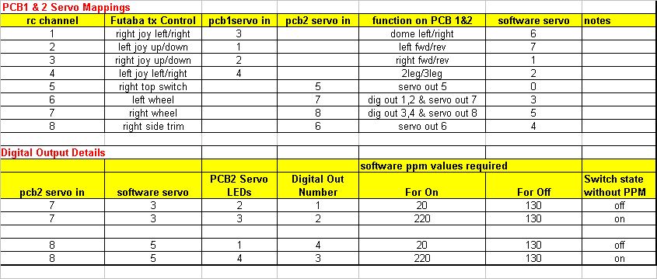

Analogue Input Mappings

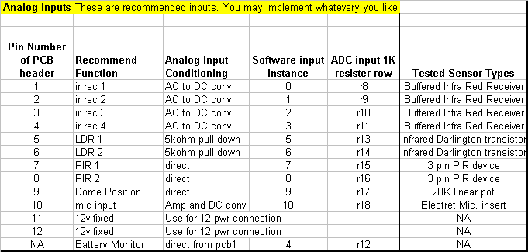

Tested Sensors

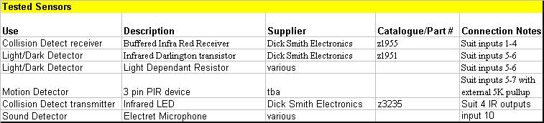

Optional Components on PCB2

You will notice there are a few “optional” components on pcb2. These are described here…

Passive components around the parallel port.

These should not be needed with recent PCs and laptops.

Capacitors are C100-C111. All would be 220pf. They may be installed if you find you are picking up noise which is causing the parallel communication to be unreliable – most likely from a long ribbon cable (>2m) in a noise environment. The downside to installing these caps is that they add about a 200nS delay in communication – which will not be a problem with Qbasic programs…

Resistors are not itemised but the 13 positions marked “Pull up Res”. These would all be 10K ¼ watt.
These optional resistors are to ensure compatibility between TTL and CMOS devices. They only need to be installed if you find you cannot reliability communicate with the parallel port.

Optional TTL Digital output headers (Con 189- 190) – See below

Making DIGITAL OUTPUT connections

High Current PPM digital outputs o1, o2, o3, o4
These are driven by four IRFZ44N P channel MOSFETs. They are Active LOW outputs.
I have tested 10Watt halogen lamps using the PCB1 provided 12V rail.
I have tested 20Watt halogen lamps using a direct 24V connected to the common terminals
NOTE: Ensure you disconnect the 5-12V select link prior to connecting the external voltage or major damage will result!!!

16 x Latched (Con 192-193) - Direct LED Connections using onboard resistors
These allow two 8x2 header IDC cables to be connected to the pcb to drive up to 16 LEDs or other low current devices. They are Active LOW outputs.

16 x Latched (Con 202-203) -Grounded low current
These allow two 8x1 headers to drive up to 16 devices such as LEDs, solenoids, Globes, Small DC motors etc. They are Active LOW outputs.

16 x Latched - TTL outputs (Con 189- 190) – Optional Connector
These allow interfacing with TTL/CMOS logic devices directly.
They are Active High (5V only) outputs.

Examples of driving devices

