4 Motor Controller User Guide
31st March 2005

4 Motor Controller User Guide 1
Usage Precautions to be read prior to use!!! 1
Perform initial testing with lower value main and Motor fuses 2
Adjustments with power applied 3
Fuses 3
Sensible use… 3
Adjustment of variable 3 – 22Volt Output 3
Connection Diagram 4
Connection Descriptions 4
Use in 12V Systems 5
Motor Wiring and Grounding 5
LEDs Indicators 5
Using the Battery Charger Circuit 6
RC Connections 8
Radio Control Receiver Power 9
Use of RC/PC link switch and PCB2 connector 9
Connector to PCB2 pinnout – 16 pin header 9
Mapping Joysticks to Motor Drives 9
Zero position Centering of the motor outputs 9
Using the Motor end run sense inputs 10
Fitting FET heatsinks 11
FET Heatsink Design 1 - using C shaped or channel Aluminium section. 11
FET Heatsink Design 2 - using 1.2mm x 12mm alu strip Aluminium section. 14
FET Alignment Problem 15
FUSE Table 16
Trouble Shooting 16
For those who remove and re-mount the Heatsink 17
A Warning about Noise 17
PCB1 FET replacement offer 18

Usage Precautions to be read prior to use!!!

Disconnect Battery connection at Battery terminal or external switch before attempting to work on the PCB (Printed Circuit Board). Work includes;
- Changing Fuses.
- Adjusting 3-22V trimpot. (unless you have a plastic driver)
- Connecting or disconnecting terminal connections of any kind
- Removing or reconnecting the heatsink

Note that if the heatsink is removed or added for any reason, the user must ensure that the rubber LM350 regulator insulators are re-installed. Use only plastic screws to secure the regulators to the heatsink. Use of a metallic screw will short the regulators and potentially damage them. This kind of damage will not be covered by warranty.

If any mounting hardware such as screws or bolts are added to the heatsink, the user must ensure that the hardware does not touch the solder tracks or components.

When installed in a robot, or anywhere else, the user must ensure that no metal shavings or wires etc fall onto the PCB. These can cause shorts which can blow up the PCB.

Note that under normal Operation the PCB heatsink will become HOT. Be careful not to burn yourself!
Ensure that your robot has some kind of ventilation and that robotic components that may be damaged by heat are not located in close proximity to the heatsink.

Double check all terminal connections prior to applying power. Units damaged through incorrect wiring will NOT be covered by warranty and may become irreparable.

Ensure wires connected to terminals are striped and soldered neatly to prevent any shorting between terminals.

Do not allow moisture on the PCB.

Do not allow objects to fall on the PCB.

Perform initial testing with lower value main and Motor fuses
PCBs that shipped prior to 20/3/05 have a problem with the fuse ratings installed.
It has been seen that with sufficient motor load the IRF9540 drive FETs can get hot enough to blow – without blowing the fuses. Another condition that will cause damage is grounded/common motor wiring as described in this document – Please check motor wiring as advised in this document check prior to powering up!
On PCBs shipped prior to 20/3/05 to avoid damaging the FETs, the recommendation now is to replace the 35 amp 3ag main fuse with a 15amp fuse and each 20 amp 2ag motor fuse with a 10 amp fuse – BEFORE USE. In this way, if you wire up something incorrectly, or pull greather than 10amps out of your motors, or are suffering from noise in your RC system then just the fuse will blow - not the fets..
Please refer to the section on FET heatsinking and the fuse-table for more information on upgrading these fuse values. PCBs shipped after 20/3/05 have the correct lower value fuses and also have the IRF9540 FETs replaced with IRF4905 FETs. (Please see FET upgrade offer at the end of this document for information on how to upgrade your FETs).

Adjustments with power applied
Adjustments to pcb pots should only be made with power applied if a plastic screwdriver is available and if you are not likely to short any part of the PCB to the body of the robot, or to any other metallic object such as loose wires or your jewellery.

Fuses

Do not install fuses of a higher current rating than that advised in this document. Doing so may cause irreparable damage to the pcb and components and will not be covered by warranty. Warranty will be void if damage has been caused though lack of adherence to any of the above precautions.

Once again, do not attempt to change fuses with the power applied…DOUBLE CHECK!

Sensible use…
Swinging the PPM signal for each motor from fwd to rev quickly will cause a large amount of current to flow through the FETs, which may blow the motor fuses, and with repeated misuse, may blow the FETs. This fast swing will also occur if you use a digital switch on you radio transmittor. For example, most 8 or 9 channel transmitters have switches for channel 5 or 6 to allow rapid deployment of model plane landing gear etc.
If should avoid using these switch controlled channels on the proportional drives on pcb1. Rather, these should be reversed for the ppm switches found on pcb2.

Remember that this controller is not a toy. Do not allow children to overdrive the input signals or crash a robot into people, animals or objects. I will not be liable for any damage injury or death caused by use of misuse of this product.

Adjustment of variable 3 – 22Volt Output

Due to it’s proximity to power components, adjustment to this adjustment pot with power on can ONLY be made with a PLASTIC flat blade screwdriver.
Use a digital voltmeter to read output voltage with or without load applied.
Turning the adjustment pot anticlockwise will increase the voltage. Check below drawing for location of this pot.

Connection Diagram
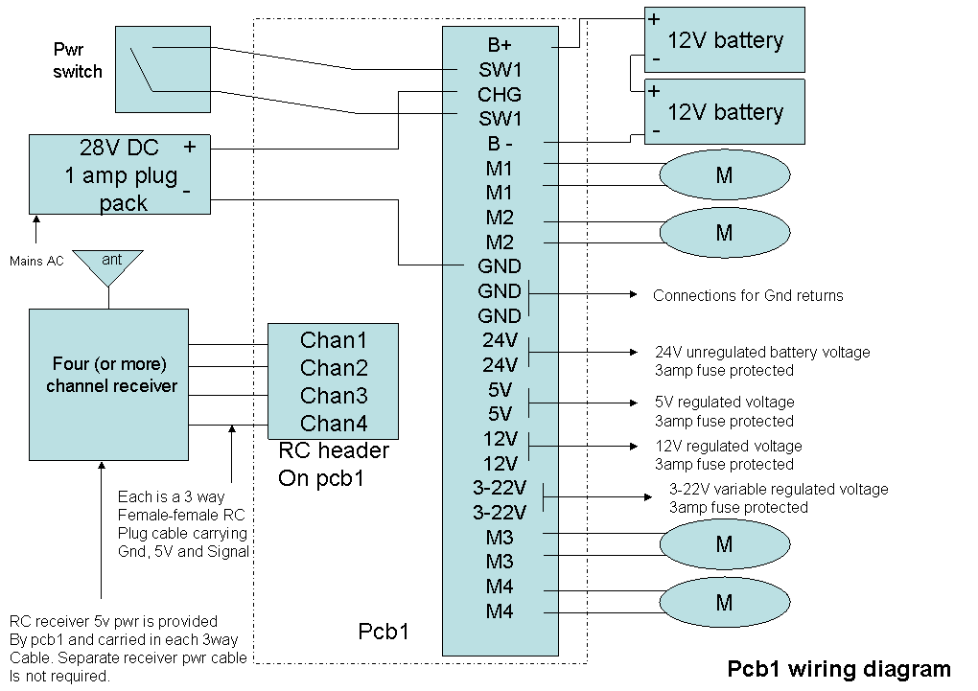

Connection Descriptions
- B+ Connect the + (red) lead of your 24V battery system here
- SW1 (both terminals) Connect a high current SPST switch across these
- B- (all terminals) Connect the – (black) lead of your batteries
- GND (all terminals) Connect grounds of external devices – e.g. sound card
- M1 both terminals Connect motor 1 – polarity to suit your motor wiring
- M2 both terminals Connect motor 2 – polarity to suit your motor wiring
- M3 both terminals Connect motor 3 – polarity to suit your motor wiring
- M4 both terminals Connect motor 4 – polarity to suit your motor wiring
- 24V 24V unregulated battery voltage – 3 amp fuse protected
- 12V 12V regulated voltage – 3 amp fuse protected
- 5V 5V regulated voltage – 3 amp fuse protected
- 3-22V regulated variable (pot) voltage – 3 amp fuse protected

Use in 12V Systems
The Motor Controller CAN be used in 12V systems. Just connect the Battery positive terminal to the B+ terminal.

A couple of notes;
- The 12volt output regulator will not work in this configuration. (The asociated resistors could be changed to allow use as a lower voltage regulators – e.g. 9V
- The 3-22Volt output will be limited to 10V max
- The external charger input voltage should be about 15Volts DC
- LEDs will be dimmer
- Motors will spin slower

Most 12V motors can be run off 24V without damage. For example I have been running 12V wiper motors as main drive motors in my R2 for four years without damaging the motors. You will have to look up the specs yourself however. I will not be responsible for damaged motors!

Motor Wiring and Grounding
Some motors have one of their terminals common with the chassis of the motor. E.g. car wiper motors! There are two possible problems with this:

- If your robot chassis is grounded (to the same point as the – Battery terminal) and the motor is mounted directly on the (conducting e.g. aluminium) chassis, then one side of the motor will be grounded. This will damage the Motor Controller.

- If the conducting chassis is common between two or more motors then one side of multiple motors will be connected together. This will cause multiple motors to drive simultaneously and can damage the motor controller.

The solution to both of these cases is to insulate the motor from the chassis. E.g. rubber washers. I will not warrant motor controllers damaged through the neglect of this issue. To test your motor, simply use an ohm meter to test the resistance between each of the motor terminals and the chassis of the motor. If it is not open circuit then you need to insulate the motor body from the chassis.

LEDs Indicators

Power LEDS
There are several power an signal LEDs on the PCB.
Each power output has a LED. Under normal operation you should see LEDs light up for;
- 24V Unreg outputs
- 12V reg outputs
- 5V reg outputs
- 3-22V reg outputs
- Main 24V to FETs

If any of these LEDs do not light up, power off and check the associated Fuse.

Motor Drive LEDs
When driving the motors with PPM signals, you will see the left and right drive LED for each motor light up depending on which position you push the joystick to. These will light up as long as the 4 x 10 amp or 20 amp motor fuses are OK, even if the Motors themselves are not connected. If they do not light up, check your RC connections and 20amp fuses.

Using the Battery Charger Circuit
There is a 1.2 amp constant current charger circuit on the PCB.
Constant current regulators are commonly used to provide a low cost safe battery charge current. To use this circuit, a suitable DC supply is required.
The Four Motor Controller is optimised around a 24V battery supply.
24Volts provides a more efficient drive voltage for most DC motors.
In my Robot, I use two 7ampere 12 Volt sealed lead-acid batteries in series.
The PCB1 constant current charger circuit will charge this load in about 7 hours.
Your DC supply should provide 26 to 34 Volts DC at 1.2-2amps.
A suitable supply could be built as follows;
An 18-24 Volt output, 120 to 240 Volt input AC transformer (that provides enough current) is connected to the AC connection of a 2amp bridge rectifier. A large capacitor (of sufficient voltage!) is connected across the DC output to smooth out the DC. Below is a circuit diagram. This DC output is then connected to the GND and CHG connectors on PCB1.

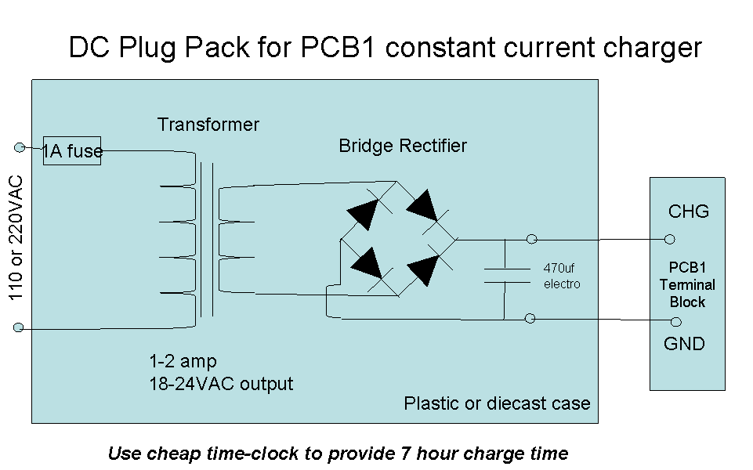

The Battery is connected to the B- and B+ connections of PCB1 as shown in the connection diagram. The Battery will charge regardless of the position of PCB1 SW1. You may be able to find a suitable DC plug pack from your local electronics supplier, however you will find that most provide a 12V output only, forcing you to get the bits and pieces an put them in a suitable box. Please be extremely careful if building your own DC supply, as mains voltage AC can be fatal.
The other thing to be careful of is that the charger should be disconnected after about 7hours. Overcharging of the batteries will shorten their life considerably. A simple mains time clock can be used to do this. These are available almost anywhere. Remember however that a time clock will charge the batteries for the same period every day. So don’t make that period too long.

Note that you do not have to use this charge circuit to charge your batteries. There are other, faster battery chargers available these days for less than $100. However again these are mostly for 12V systems. If you use an external system, just connect it directly across your battery terminals as shown in it’s user guide. Do not attempt to power the PCB1 directly from a charger, as they cannot deliver the current that a battery can and that the motors require. Note that AC noise introduced by an external charger may cause the motors to behave erratically even with the batteries connected – you may find that it is best to wait until the batteries are charged and the charger disconnected prior to operating your robot.

RC Connections
I recommend an FM RC transmitter and receiver. AM sets whilst cheaper suffer from more noise interference and could lead to blown fuses. I use a Futaba 8 channel system.
The first 4 channels, 1-4 are used for PCB1. Channels 5-8 are used for PCB2.

You will need to acquire four female to female mini 3 way plugs and cables, one per channel.

These are not commonly available…
Most Hobby shops can provide cables that are Male to Female as they are intended to extend a RC receiver to servo link.

But the problem is that on pcb1, I have provided a male header connection and so is the connection on all RC receivers. Therefore what you need is four Female to Female three way leads.

Here are some options for acquiring these;

Option1
Most hobby shops sell the 3 way plugs with soldered leads. You will need to purchase eight of these and solder four pair together. The colours mate to each other. i.e red to red, orange to orange and black to black. Make sure you insulated the soldered connections with heat shrink or at worst with electrical tape.

Option2
Digikey sell a 36 way female connector strip which can be cut up into 12 lots of 3. Twelve way Ribbon cable can then be used to solder 4 of these 3 way female plugs to each end of the cable. This would be the cheapest way I can see of building these cables, though a fair amount of soldering is required.

Can you or your friend solder? If so, order 1 x 36 way female connector strip, buy some ribbon cable from the local electronics shop and some heatshrink and solder them up.

Go to Digikey;

http://www.digikey.com
Digikey part number for 36 way female strip;
929974-01-36-ND - need Quantity 1 per pcb1

Digikey part number for heatshrink;
SFTW2018K-5-ND Quantity 1 for 5 foot length (or just get at local electronics shop)

Servo wire - just buy some multicolor ribon cable 16 way or greater, 1 metre length from your local electronics shop. Keep the length of the cables to less than 1 metre.

Note that it doesn't really matter if you are using Futaba or Hirec or whoever as your RC receiver. The problem is all these RC receivers use a small interconnector spacing for their connectors. They are non standard in the electronics world (2.54mm) making it a real expensive pain to build your own.

Note; Try to locate the RC receiver 30 centimetres away from the PCB to avoid any IFreq from causing noise problems.

Radio Control Receiver Power
Most RC receivers have a separate header for connecting 4.8Volt batteries.
They then supply this voltage to their servos via the red and black servo wires.
In my design, pcb1 supplies 5Volts to the receiver via the red and black wire (black is gnd) – so the separate receiver header does not need to be connected to anything. Note that the orange wire in a standard servo cable is the ppm signal.

Use of RC/PC link switch and PCB2 connector
This is for use with either my pcb2 or a 2nd set of four PPM inputs.
These PPM inputs could come in from a 2nd RC receiver or more likely (as in my pcb2) a serial to ppm micro-controller.
For normal RC control leave the link in the RC position.
When used with pcb2, the link would be replaced with a connector flying lead to a DPST switch mounted on the body of your robot to allow the selection of RC or computer control. The ribbon connector (supplied with pcb2) also carries power and a 24V battery monitoring voltage to pcb2.

Connector to PCB2 pinnout – 16 pin header

Pin # | Pin2 | Pin4 | Pin6 | Pin8 | Pin10 | Pin12 | Pin14 | Pin16
Function | 12v | 12v | 12v | gnd | gnd | gnd | gnd | Batt-lvl
Pin # | Pin1 | Pin3 | Pin5 | Pin7 | Pin9 | Pin11 | Pin13 | Pin15
Function | 5v | 5v | 5v | Ppm5 | Ppm6 | Ppm7 | Ppm8 | Ppm7

Mapping Joysticks to Motor Drives
You should choose the channel mapping such that the two joysticks are set to drive the robot like a tank. I.e. Push both sticks up and the robot moves forward. Pull both back and the robot moves in reverse. Push the right stick up and the robot turns left. Push the left stick up and the robot turns right. This requires only two channels e.g. 1 and 2.
The third channel can be used for the dome left and right. The fourth for whatever else you need – e.g. periscope motor up and down. (Again, please only use joystick controlled channels for pcb1. Switch controlled channels should be reserved for pcb2)

Zero position Centering of the motor outputs

Each motor drive has a pot for Centering (no output) of the motor Fwd/Rev position to match your receiver channel.
Assuming you have connected the RC Receiver to the Motor Controller you are adjusting;

- Set your RC transmitter to the middle or off position using the joystick and trim controls.
- Disconnect Motor wiring to drive Motors
- Turn on Motor Controller PCB
- Turn the associated pot clockwise or anticlockwise until both associated LEDs go out.
- Turn off Motor Controller
- Reconnect Motor
- Turn on Motor Controller and RC transmitter and Test

Note that without RC transmitter signal being received the Motor will not drive fwd or reverse.

Using the Motor end run sense inputs
Each motor has two 2 pin headers that are normally shorted with a link.
Each of these links may be removed and a 2 way socket and lead connected to a normally closed end run SPST switch.

This allows you to position two end run switches per motor. For example, with R2D2s dome you may wish to limit the travel of the dome to 270 degrees so that dome wiring connecting between the body and dome is not twisted and worn out. To do this you would locate two switches in such that a tab on the dome creates an open cct condition when the dome is at the desired end of run. The motor will still drive in the reverse direction (unless you have also opened the other switch). These switches could also be used to stop the main drive motors of R2 if a switch sensor was positioned on the front of each foot. The following diagram shows the wiring of M1 for end run sense.

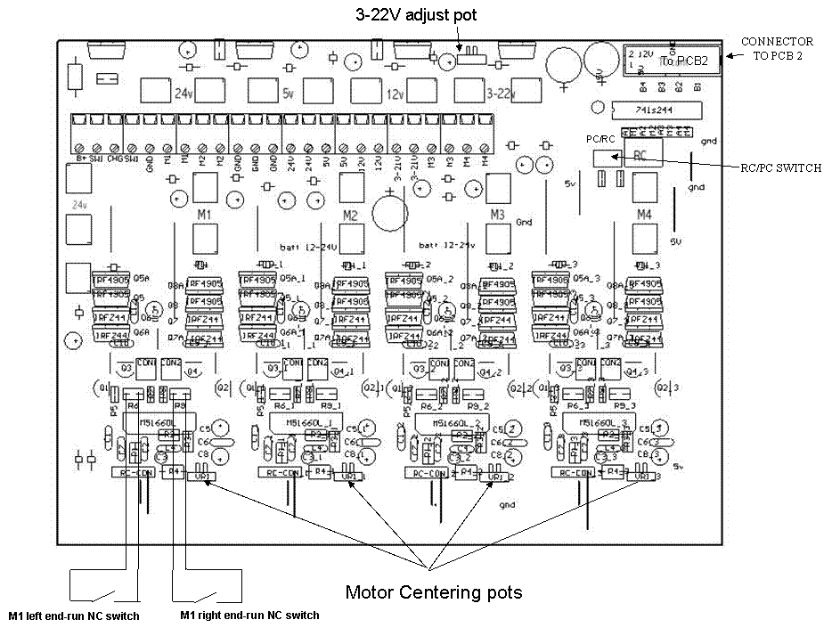

Fitting FET heatsinks
FET heatsinks are required if you are running the original IRF9540 FETs on motors that draw current above 10amps. This is regardless of whether you have PCBs fitted with the more powerfull IRF4905. Basically any heavy aluminimum robot will need the FET heatsinks installed.

Here are the design details for two different designs;

FET Heatsink Design 1 - using C shaped or channel Aluminium section.
Using this design 15amp fuses may be used as the four motor fuses with a 25amp main fuse. Without the heatsinks and with IRF9540, each motor controller fuse MUST be limited to 10amp fast blow.
The P channel IRF9540N FETs (4 per motor drive) are the ones requiring heatsinking above 10amps. The other N channel IRFZ44N FETs are fine, and do not get hot. So only each IRF9540N needs heatsinking. However with this heatsink design, most of the the IRFZ44N also get some heatsinking due to the mounting method. This is a good thing.
There are 16 of the IRF9540N on each pcb, 4 per motor drive. You can identify them easily by the color of their metal tag. It is a brass color vs the Z44N fets which are a silver color.
Fortunately with the pcb fet layout, the metal tags of each of the strips of 4 fets are electricaly common. So a bolt can be passed through the 4 inline fets to secure the heatsinks.
The below photo shows the pcb with all 4 drives fitted with the heatsinks.
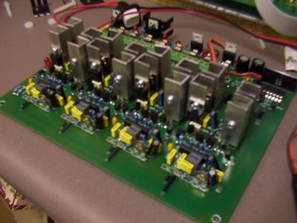
I purchased the channel alu strip from the local hardware store.
The profile of the strip is 12x12x1.5mm. Each heatsink is a 30mm length. You thus need 31x16 = 496mm length for one pcb. I cut the strip with a hacksaw.
The holes need to be located at 15mm, ie mid way up the strip and 5mm in from the edge. You need to trim all the alu shaving off ofcourse. The hole size is 3mm.

The bolts are 1/8inch x 25mm (god knows why they still mix imperial and metric!). The nuts are 1/8inch. I bought these nuts and bolts in a 50 pack for a few bucks each.
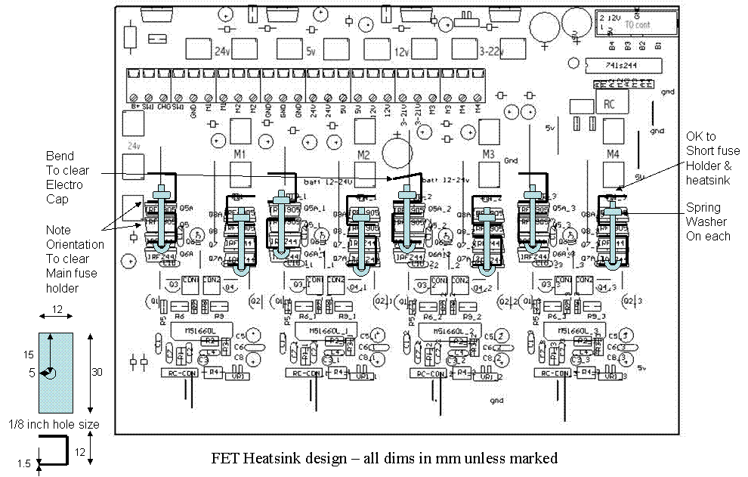
You must ensure that the nuts are done up securely and will not come loose (use spring washers). If the heatsinks are loose, they could short out onto each other. This would at the very least blow fuses, however the FETs may blow as well. I will not provide warrenty for this kind of damage.

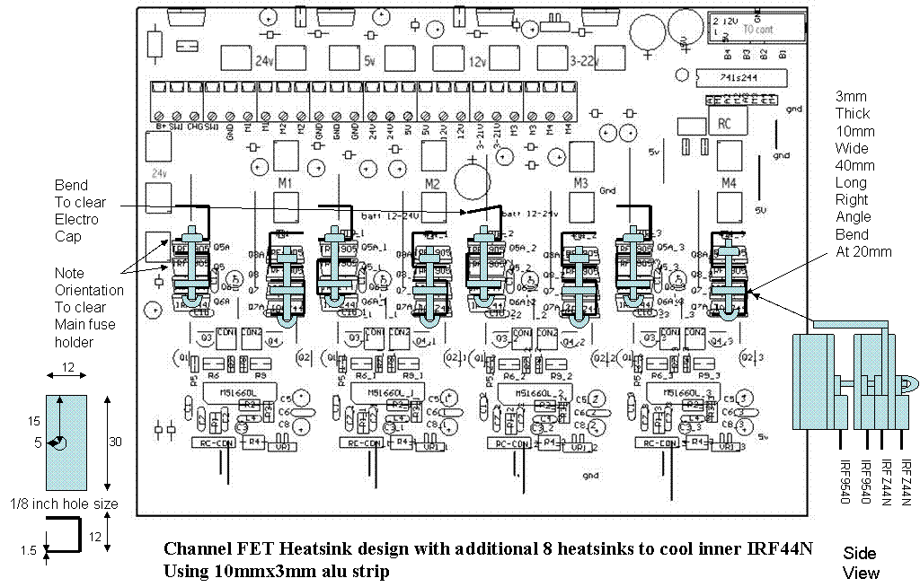

The above diagram shows the addition of 3mm alu strip to provide heatsinking to the inner IRFZ44N fets. This is required if pulling over 10amps continuously.

FET Heatsink Design 2 - using 1-1.2mm x 10mm alu strip Aluminium section.

This is a better design that provides good cooling of all fets and will work well with optional muffin fan (possibly driven off 12V output)

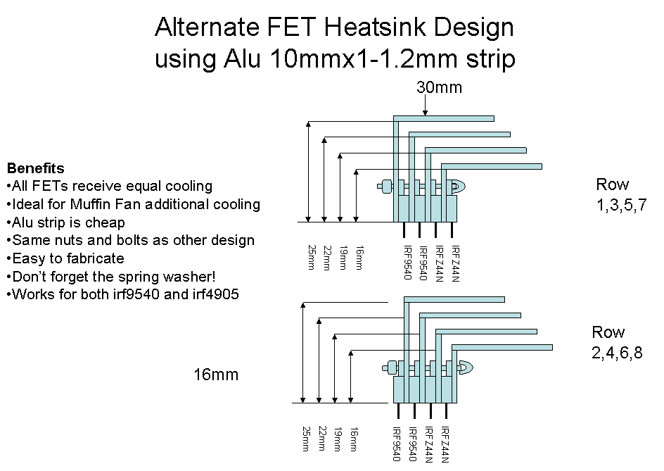

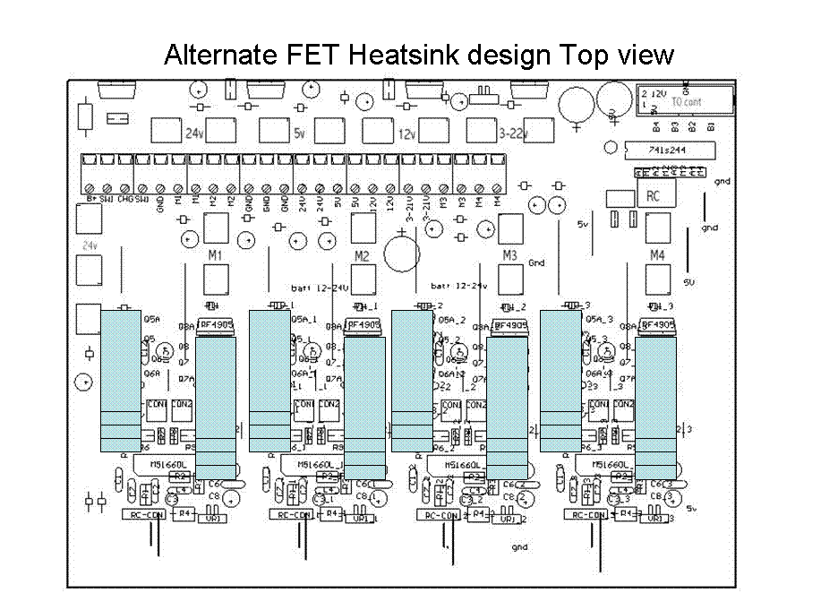

Alternate design applied to M1

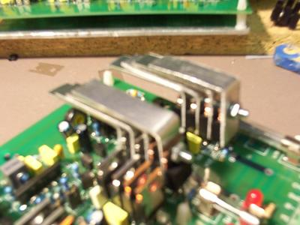

FET Alignment Problem
Now for the bad news - On some of the pcbs the fets do not line up perfectly. This is because we did not realise originaly that the IRF9540N would require heatsinking- so no attention was made to ensuring the assembler lined the fet holes up..
To rectify this, the main heatsink needs to be taken off and the fets re-aligned using a soldering iron. If you are not confidant in doing this, you can send your pcbs to Tom Jozwiak in the USA who has offered to fix blown pcbs and help with getting the heatsinks fitted. Alternatively you can return the pcb to me. See the FET upgrade offer at the end of this document.
Note that future pcb1s will NOT ship with these heatsinks fitted although they will all have the higher grade IRF4905 P channel FET.
Once again, with the fet heatsinks and IRF9540Ns, the fuses on each motor drive fuse can be 15amp, with the main fuse 25amp. Without the fet heatsinks the motor fuses MUST be 10amp fast blow or 5amp slow blow.
Also note that the addition of the fet heatsinks makes the pcb 52mm thick, so please allow for this when figuring out where to locate it in your robot.
Also note, that with IRF9540N, that the fet heatsinks get VERY hot under high motor load, so ensure nothing is touching them. You may also wish to install a muffin fan near the pcb to keep things cool.
Note that with new IRF4905s, each motor drive fuse will be able to be 20amp, with the main still 25amps. Although these FETs have a very low “ON” resistance they will still get hot when drawing more than 10amps (as will the IRFZ44Ns).
Again, regardless of the fet type installed in your PCB, you WILL require FET heatsinks if you have a heavy robot and are pulling more than 10amps for more than a few seconds on the motor drives.
You may find that you can get away with just putting the heatsinks on the motor drive fets. Dome drive fets and other none load bearing motors should not require fet heatsinks.

Note that if you find you blow the 25amp main fuse under multiple-motor heavy load with the IRF4905 FETs, you will need to increase the current handling capability of the 24V rail of the pcb. This will involve the installation of power rail bus bars on the 24v and posibly the gnd rails. Email me if you need to do this.

FUSE Table
To clarify the fuse options for the pcb, please refer to the following table;

All values in amps – fast blow | Main Fuse x 1  3AG | Motor Fuse x 4  2AG | 24V fuse  2AG | 5V, 12v, 3-22v Regulator Fuse x 3  2AG
IRF9540N no heatsink | 15 | 10 | 20 | 3
IRF9540N with  FET heatsinks | 25 | 15 | 20 | 3
IRF4905 without  FET heatsinks | 25 | 15 | 20 | 3
IRF4905 with  FET heatsinks | 25 | 20 | 20 | 3

Trouble Shooting
- Once again – Double check all your connections before applying power. If you have any doubts, please email me at mhamester@yahoo.com

- Check that your Battery is fully charged. Use a meter to check the Battery voltage. It should be 23V or higher.

- Check the RC connections are around right way. Sig is normally orange, 5V is normally red, and ground is always black. I have marked these on the PCB.

- Check your transmitter has charged batteries

- Check you have matching crystals in your transmitter and receiver

- Try another RC frequency if you have spare crystals. You may be getting swamped by a local source

- If you are having noise problems, try to locate the RC receiver (and transmitter) 30 centimetres away from the PCB to avoid any IFreq. from upsetting the Motorola servo ICs.

- If you are having noise problems, try turning off and disconnecting the charger, as AC hum leaking though it can cause problems. (obviously you will need a fully charged battery)

- If the 3amp voltage output fuses are blowing, remove any external load and replace the 3amp fuse. If they continue to blow, repair is required. Ensure there are no shorts from the regulators to the main heatsink. Ensure the regulators are securely tightened to the heatsink via the rubber insulator.

- If the 3AG main fuse is blowing, disconnect all motors. If it continues to blow, repair is required. Please email me.

- If a 2AG motor fuses blow, disconnected the appropriate motor and replace the fuse. Check the motor for shorts between it’s two terminals and also to ground as discussed in this document. If the motor fuse continues to blow with the motor disconnected, check your wiring to the motor, it is most likely shorted so disconnect at the PCB.

For those who remove and re-mount the Heatsink
I do NOT recommend you remove the heatsink unless you have to to change or align FETs. If removed, please observe the following when remounting to the PCB…

If the LM350 regulators are not hard and flat up against the rubber insulators, and tight via the nylon screws they will overheat and the voltage outputs will shut down due to thermal protection feature of these LM350 ICs.

Make sure the nylon screws are tight. Be sure not to overtighten however as they are very easy to strip. If you do strip the thread, buy some more at the local electronic shop. Both the screw and nut will be damaged so replace both.

At the end of this process, the way to check that there is no gap between the regulators and the heatsink with a modeling knife/scalpel. Run it down between the regulator and the rubber insulator. If properly mounted the blade should not be able to get in-between at all…

A Warning about Noise
You must ensure that noise on the RC signal and DC power is not present. If it is, you will notice the motors will shudder and move randomly when the joystick is not being moved. The LEDs on the controller will also flicker. If this occurs, I recommend you turn the controller PCB off until you have eliminated the source of the noise.
Try a standard servo in place of the PCB and check that the servo does not shudder under normal operation.
The problem is that this kind of noise can cause the drive FETs to become overheated due to surge currents and eventually destroy themselves. They may do this without blowing the main fuse. This will require that the unit be sent back to me for repair. (non warranty) Typically 1 or more of the 8 FETs in the H-bridge will be destroyed and the repair will take at least two weeks plus shipping time…Cost will vary depending on the damage. I will not pay the shipping fee.

PCB1 FET replacement offer

From deadshort testing recently performed it has been found that the IRF9540 FETs used on the initial 23 pcbs are only good for 10amps per motor or 15 amps with heatsinking.
Without heatsinking it has be seen that even momentary heavy loads can pop these FETs.

The board was sold as 20amp per motor.
Unfortunately the testing done on the prototype did not drive this FET hard enough.

I therefore make the following offer;

I have received 650 P channel IRF4905s. These FETs have a MUCH lower ON resistance and are as robust as the N channel IRFZ44N Fets also used on the board.

All future pcb1s will ship with the IRF4905 and IRFZ44N Fets only.

For those who have already received their pcb, (prior to 20th March 2005) you have the following choices;

1. Do nothing other than replace the motor fuses with 10amp fast blow or 5amp slow blow. The main fuse should be replaced with a 25 amp fast blow. Note that I strongly recommend that you do not do nothing. You should at least do number 2 below...

2. Install the heatsinks as documented in this. (Photos are already available on the yahoo r2 site under photos/marks pcbs). You can then use 15amp fast blow fuses for each motor - the main should still be 25amp. You may want to take this option in the short term if
You need to show off your R2 in the short term...

3. Accept a set of 16 FETs from me and install yourself. I will post together with instructions free of charge. Note however that I can't be responsible for you destroying the tracks or putting them in the wrong way. Only choose this path if you are very good with a soldering/desoldering iron or have a friend who is.

4. Mail the PCB to Thomas Jozwiak in the US. He has offered to upgrade the pcbs for no charge. I will be sending him a quantity of FETs. However I would suggest that you would want to pay Tom for his time for doing this. It is about 30-120 minutes work depending on any damage done to the pcb from the IRF9540s....

5. Mail the PCB to me in Australia. I will replace and test all for no charge however I would ask (though not demand) that you would paypal me $40 to cover the cost of the shipping and labor which I will outsource.

Sincerely,
Mark Hamester
mhamester@yahoo.com

NOTE: Specificatons can change without notice. Please email Mark Hamester if you are unsure of anything in this document – prior to applying power to your pcb1.

